

DEPARTMENT OF MATHEMATICS

ACADEMIC YEAR 2017-2018


DEPARTMENT OF MATHEMATICS
Result analysis of B.Sc ( MPC & MPCS ) 2017-2018
SEMESTER | PAPER | Name of the paper taught | No. of Students Attended | No. of Students Passed | Pass percentage
I | Peper-I | Differential Equations | 6 | 5 | 83.33
II | Peper-II | Solid Geometry | 6 | 3 | 50
V | Paper- V | Ring Theory and Vector Calculus | 7 | 5 | 71.43
V | Paper- VI | Linear Algebra-I | 6 | 4 | 66.66
VI | Paper- VII | Laplace Transforms-I | 7 | 6 | 85



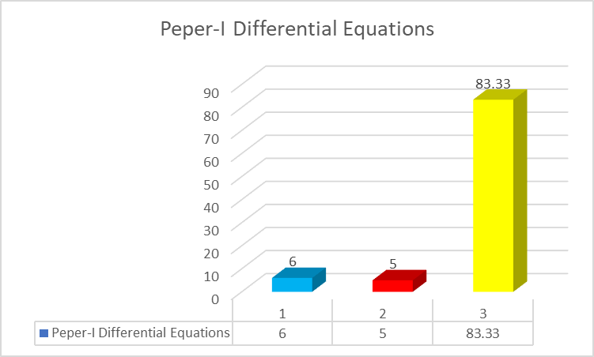

DEPARTMENT OF MATHEMATICS

I – YEAR B. Sc. (M. P. C & M.P.Cs) SEM-I SUBJECT WISE RESULTS, NOV/DEC – 2017.

S. N. | Hall Ticket Number | Name of the Student | Eng | T/H | Maths | Phy | Chem | H.V | E.S | Phy.  Pract | Che Pract | Pass/Fail | GP
 | M. P. C
1 | 170270633001 | S. Santhi | B | A | A | A | A | B+ | A | O | O | Pass | 8
2 | 170270633002 | M. Krishnamurthy | A | O | B | B | B | A+ | A+ | O | A+ | Pass | 7.4
3 | 170270633003 | P.Mallikarjuna | B | B+ | B | B | F | B+ | B+ | A+ | O
4 | 170270633004 | S.Ramesh | B+ | A | F | B+ | F | A | A+ | O | O
5 | 170270633005 | B.Sundhar | B+ | AB | AB | AB | AB | AB | AB | O | A+
 | M. P. Cs |  | Eng | T/H | Maths | Phy | Comp | H.V | E.S | Phy.  Pract | Comp  pract | Pass/Fail | GP
6 | 170270633006 | A.Mallikarjuna | B+ | A+ | B | A | B+ | A | B+ | O | A+ | Pass | 7.64
7 | 170270633007 | C. Sandhyarani | AB | AB | AB | AB | AB | AB | AB | A+ | O |  | -
8 | 170270633008 | K.Lavanya | B | A | A | B | B | O | B | O | A | Pass | 7.1

Number of Students Appeared : 06
Number of Students Pass : 05

Pass Percentage : 83%

DEPARTMENT OF MATHEMATICS

III – YEAR B.Sc. (M.P.C. & M.P.Cs) SEM-V &VI SUBJECT WISE RESULTS, NOV/DEC – 2017.

S. No. | Hall Ticket Number | Name of the Student | Maths  V | Phy.  V | Che  V | Maths  VI | Phy.  VI | Che  VI | Phy.P.  V | Che.P  V | Phy.P  VI | Che.P  VI | Pass/Fail | GP
 | M. P. C
1 | 150270633003 | I. Ramanjaneya Reddy | B | B | B | F | B | F | O | O | O | A+
2 | 150270633004 | C. Gundumallaiah | F | F | AB | AB | AB | AB | A+ | O | A+ | A+
3 | 150270633005 | P.Thirubabu | B | A | B+ | O | A | B+ | O | O | O | O |  | 8.3
4 | 150270633006 | D.Kishore | B | O | A+ | A+ | A+ | A+ | O | O | A+ | O |  | 8.8
5 | 150270633007 | J.Pavan Kumar Reddy | F | F | F | F | F | B | O | O | O | A+
 |  |  | Maths  V | Phy.  V | Comp  V | Maths  VI | Phy.  VI | Comp  VI | Phy.P.  V | Comp.P  V | Phy.P  VI | Comp.P  VI | Pass/Fail | GP
 | M. P. Cs
6 | 150270633008 | G.Hemanth Kumar | B | A+ | B+ | A+ | A | B+ | O | O | O | O |  | 8.27
7 | 150270633009 | J.Pavan Kumar Reddy | B | A | B+ | O | B | B | O | O | O | O |  | 8.03

SEMESTER | PAPER | Name of the paper taught | No. of Appeared | No.of Passed | percentage
V | Paper- V | Ring Theory and Vector Calculus | 7 | 5 | 71.43
V | Paper- VI | Linear Algebra | 6 | 4 | 66.66

DEPARTMENT OF MATHEMATICS
II – YEAR B. Sc. (M. P. C & M.P.Cs) SEM-III SUBJECT WISE RESULTS, Mar/April – 2018.

S. N. | Hall Ticket Number | Name of the Student | Eng | T/H | Maths | Phy | Chem | F.CI | F.CII | Phy.  Pract | Che Pract | Pass/Fail | GP
 | M. P. C
1 | 170270633001 | S. Santhi | AB | AB | AB | AB | AB | AB | AB | A | AB
2 | 170270633002 | M. Krishnamurthy | B | O | B | B | B | B+ | B+ | B+ | AB
3 | 170270633003 | P.Mallikarjuna | B | A | AB | AB | AB | AB | AB | A+ | AB
4 | 170270633004 | S.Ramesh | F | A+ | C | B | B+ | B+ | B+ | B+ | AB
5 | 170270633005 | B.Sundhar | - | - | - | - | - | - | - | - | - | - | -
 | M. P. Cs |  | Eng | T/H | Maths | Phy | Comp | F.CI | F.CII | Phy.  Pract | Comp  pract | Pass/Fail | GP
6 | 170270633006 | A.Mallikarjuna | A | A+ | B | O | A+ | A | A | A+ | O | Pass | 8.32
7 | 170270633007 | C. Sandhyarani | - | - | - | - | - | - | - | - | - | - | -
8 | 170270633008 | K.Lavanya | AB | AB | AB | AB | AB | AB | AB | B+ | O

Number of Students Appeared : 03

Number of Students Pass : 03
Pass Percentage : 100%

DEPARTMENT OF MATHEMATICS
III – YEAR B.Sc. (M.P.C. & M.P.Cs) SEM-V &VI SUBJECT WISE RESULTS, Mar/April – 2018.

S. No. | Hall Ticket Number | Name of the Student | Maths  V | Phy.  Elec | Che  V | Phy.  A1 | Phy.  A2 | Phy.  A3 | Phy.P. | Che.P | Phy.A1 P | Phy.A2 P | Phy.A3 P | Pass/Fail | GP
 | M. P. C
1 | 150270633003 | I. Ramanjaneya Reddy | F | F | B | B | F | B | B+ | A+ | B+ | B+ | B+
2 | 150270633004 | C. Gundumallaiah | B | AB | F | AB | AB | AB | B+ | A+ | B+ | B+ | B
3 | 150270633005 | P.Thirubabu | A | A+ | B+ | A | O | O | B | O | B+ | B+ | B+ |  | 8.2
4 | 150270633006 | D.Kishore | A+ | A+ | A | O | A | A | A+ | O | A+ | A+ | B+ |  | 8.72
5 | 150270633007 | J.Pavan Kumar Reddy | B+ | B+ | B | F | F | B+ | B+ | O | B+ | B+ | B+
 |  |  | Maths  V | Phy.  Elec | Che  V | Phy.  A1 | Phy.  A2 | Phy.  A3 | Phy.P. | Che.P | Phy.A1 P | Phy.A2 P | Phy.A3 P | Pass/Fail | GP
 | M. P. Cs
6 | 150270633008 | G.Hemanth Kumar | B | A+ | B+ | A+ | A+ | A | A+ | O | A+ | A+ | A+ |  | 8.27
7 | 150270633009 | J.Pavan Kumar Reddy | B+ | B+ | B+ | A | B+ | A | A+ | O | A+ | A+ | A+ |  | 8.03
SEM | PAPER | Name of the paper taught | No. of Appeared | No. of Passed | percentage
V | Paper- VII | Laplace Transforms -I | 7 | 6 | 85.71

